Synopsis

Predictive Analytics for Urban Water Demand

Problem Id: 6

Student Name: Stuti
University Roll number: 2028866
Section: P (group 2)

Student Name: Tilak Singh
University Roll number: 2028883
Section: P (group 2)

Student Name: Shaurya Mittal
University Roll number: 2028847
Section: P (group 2)

Problem Description
- Urban water management is becoming increasingly challenging due to population growth and fluctuations in usage patterns. Accurately forecasting daily water demand allows authorities to distribute water efficiently, minimize wastage, and avoid potential shortages. This project aims to design a predictive model that estimates daily water consumption using key factors such as household size, seasonal trends, and garden area.
- A dataset will be prepared that includes these variables along with recorded water usage. Machine learning methods, particularly Linear Regression, will be used to analyze the relationship between these factors and water demand. To enhance the model’s effectiveness, data preprocessing steps like handling missing data and applying feature scaling with StandardScaler will be performed.
- The accuracy of the model will be assessed through residual analysis. This project highlights the importance of data-driven solutions in enabling smarter urban planning and promoting sustainable water resource management.

Steps of Implementation

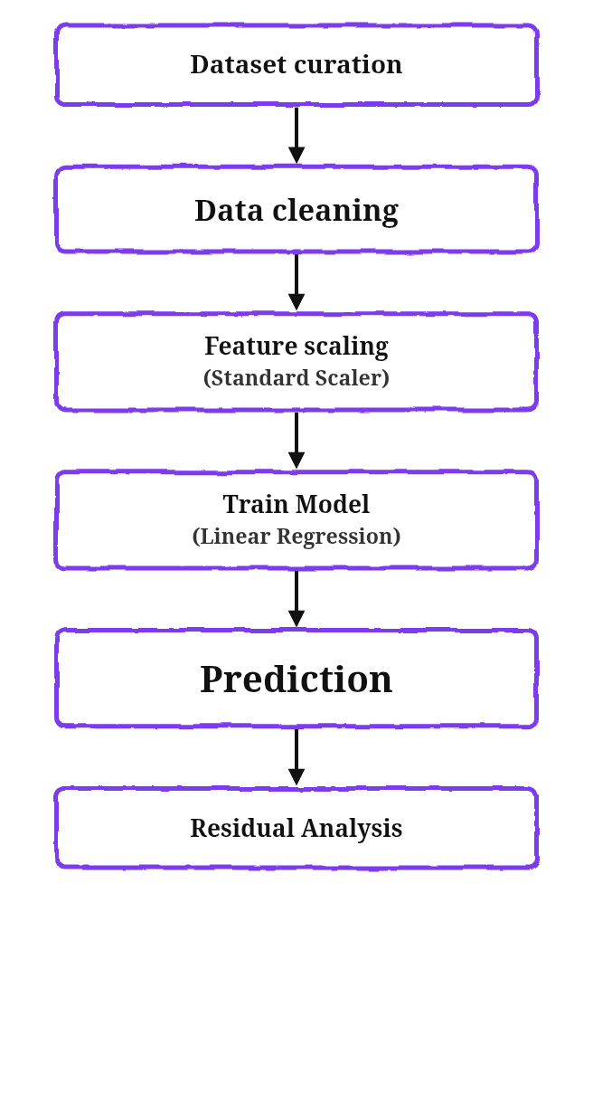

Expected Modules/ Libraries to be used
NumPy
Used for performing mathematical calculations and working with arrays efficiently.
Pandas
Helps in managing, cleaning, and organizing datasets for analysis.
Scikit-learn
Offers built-in tools for tasks like feature scaling (StandardScaler) and implementing Linear Regression models.
Matplotlib / Seaborn
Used to create graphs and charts for better understanding of data, including residual plots and prediction comparisons.

Expected Evaluation metrics and Plots to be used
- Metrics
- Mean Absolute Error (MAE) = Measures average prediction error
- Mean Squared Error (MSE) = Penalizes larger errors
- R² Score = Measures model accuracy
- Plots
- Residual Plot = Check error distribution
- Actual vs Predicted Plot = Visualize model performance

Required topics from the subject
1. Data Preprocessing: This step focuses on cleaning and organizing raw data so it becomes suitable for use in the model.
2. Feature Scaling (StandardScaler): StandardScaler adjusts the data so that all features are on a similar scale, with an average value of zero and a standard deviation of one.
3. Linear Regression: A technique used to understand and predict the relationship between input variables and the output variable.
4. Scikit-learn (sklearn) Library: A widely used Python library that provides tools and algorithms for building machine learning models.
5. Data Visualization: Involves creating graphs and charts using tools like Matplotlib or Seaborn to analyze results, such as residual plots and prediction comparisons.

Platform Required
Visual studio/ MS excel

Books and Link Sources
- Pattern Recognition and Machine Learning – Christopher M. Bishop
- Machine Learning: A Probabilistic Perspective – Kevin P. Murphy
- Data Science for Business – Foster Provost, Tom Fawcett
- Introduction to Machine Learning with Python – Andreas C. Müller
- Deep Learning – Ian Goodfellow, Yoshua Bengio, Aaron Courville
- TensorFlow Documentation
- NumPy Documentation
- Pandas Documentation
- Matplotlib Documentation
- Seaborn Documentation
- Kaggle (datasets, notebooks, competitions)
- UCI Machine Learning Repository
Prompt used for dataset for generation
Construct a structured dataset representing the selected features and corresponding water consumption values. Apply comprehensive data preprocessing techniques, including handling missing values, outlier detection, and feature scaling using StandardScaler to ensure data consistency and improved model performance. The dataset should contain at least 200 rows and the following columns:

1. Household_Size (integer: 1–10)
2. Seasonal_Index (float: 0.5–1.5 representing seasonal variation)
3. Garden_Area (in square meters: 0–200)
4. Daily_Liters_Used (target variable in liters: 100–1000)

Requirements:
- Ensure realistic relationships:
• Larger households consume more water
• Higher seasonal index (summer) increases water usage
• Larger garden area increases water usage
- Add some randomness (noise) to make data realistic
- Include a few missing values randomly for data cleaning practice
- Output the dataset in CSV format

